ISYS2077 Database Concepts

**TUTORIAL - RELATIONAL ALGEBRA**

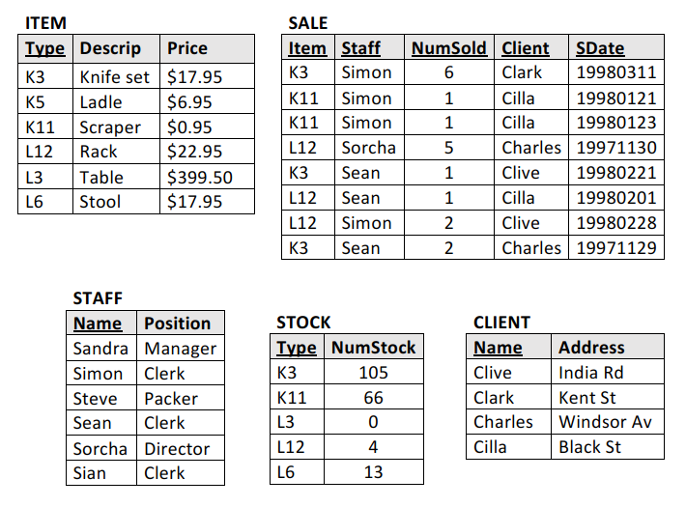

# 1. Give relational algebra expressions for the following queries

## a) What are names of the clients that bought, at least, one item?

$$π_{Client}(σ_{NumSold≥1}\left(SALE\right))$$

## b) What has Cilla bought?

$$π_{Item}(σ_{Client="Cilla"}\left(SALE\right))$$

$$π_{Descrip}(ITEM⋈_{i.Type=s.Item}σ_{ Client="Cilla"}(SALE)$$

$$π_{Descrip}(σ_{ Client="Cilla"}\left(ITEM⋈_{i.Type=s.Item}SALE\right))$$

## c) Which staff made sales on March 11 1998?

$$π_{Staff}(σ_{SDate="19980311"}\left(SALE\right))$$

## d) What items are out of stock?

$$π_{Type}(σ_{NumStock=0}\left(STOCK\right))$$

$$π_{Descrip}(ITEM⋈_{i.Type=s.Type}σ_{ NumStock=0}(STOCK)$$

$$π_{Descrip}(σ_{ NumStock=0}\left(ITEM⋈_{i.Type=s.Item}SALE\right))$$

## e) What items haven’t been sold?

$$ρ_{Type→Item}(π_{Type}\left(ITEM\right))-π_{Item}\left(SALE\right)$$

## f) Which clerks don’t have any sales?

$$π_{Name}\left(σ_{Position="Clerk"}\left(STAFF\right)\right)-ρ_{Staff→Name}(π_{Staff}\left(SALE\right))$$

## g) What categories of staff have made sales?

$$π_{Position}\left(STAFF⋈_{st.Name=sa.Staff}SALE\right)$$

## h) Have any sales of any item exceeded the current stock of that item?

$$π_{Item}\left(STOCK⋈_{st.Type=sa.Item \& st.NumStock<sa.NumSold}SALE\right)$$

# 2. Give English expressions for the following queries and determine the respective resulting relations

a) 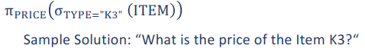

b) 

Which clients have sales from 1st January 1998?

c) 

What is the description of item K3?

d) 

Which staff positions sold item K11?

e) 

Which staff sold item Ladle to clients from Kent St?

f) 

Which staff sold item Ladle to clients from Kent St?

g) 

What are the descriptions of items in ITEM but not in STOCK?

# 3. What integrity constraints might reasonably be expected to hold for this data?

***One example: “All the columns of the table “SALE” must be NOT NULL”***

**PRIMARY KEY**

*Table* SALE *New Primary Key* SaleID

*Table* STAFF *New Primary Key* StaffID

*Table* CLIENT *New Primary Key* ClientID

**FOREIGN KEY**

*Table* SALE *Foreign Key* Item *References* ITEM(Type)

*Table* SALE *Foreign Key* Staff *References* STAFF(Name)

*Table* STOCK *Foreign Key* Type *References* ITEM(Type)

*Table* SALE *Foreign Key* Name *References* CLIENT(Name)

**OTHERS**

STOCK.NumStock NOT NULL $≥$ 0

ITEM.Price NOT NULL $≥$ 0

SALE.NumSold NOT NULL $>$ 0

SALE.SDate NOT NULL $≤$ today

# 4. Which of the following updates violates a likely integrity constraint?

## a) Add the tuple ( Null, Simon, 1, Clark, Null ) to SALE.

***Sample Solution: It violates because the columns Item and SDate cannot be NULL.***

## b) Add the tuple ( Null, Spanners, $11.95 ) to ITEM.

VIOLATE: PK Type cannot be null

## c) Add the tuple ( Simon, Packer ) to STAFF.

VIOLATE: Duplicate of PK Name “Simon”

## d) Delete the tuple ( Simon, Clerk ) from STAFF.

VIOLATE: Name is referenced in SALE

## e) Add the tuple ( Cindy, Null ) to CLIENT.

VIOLATE: Address NOT NULL

## f) Add the tuple ( L3, 5 ) to STOCK.

VIOLATE: Duplicate of PK Type “L3”

## g) Add the tuple ( K3, Simon, 1, Conrad, 19980301 ) to SALE.

VIOLATE: No record of “Conrad” in CLIENT

## h) Change the STOCK tuple ( K3, 105 ) to ( K3, 95 ).

NOT VIOLATE